SOCIAL INSURANCE = RETIREMENT

Instead of purely private pension systems, governments tax workers to provide them social security.

1. Who Is Eligible to Receive Social Security?
In Italy, a person must have worked and paid payroll tax for a minimum number of 20 years and must reach the retirement age of 67.
In the US, a person must have worked and paid payroll tax for a minimum of 10 years and must reach the retirement age of 67.

2. How Are Social Security Benefits Calculated?
Individuals pay social security contributions while working (i.e., FICA, payroll taxes). In exchange, they receive retirement benefits when they stop working till the end of their life (i.e., annuity payments). The amount of this annuity payment is a progressive function of the recipient’s average earnings (not contributions!) over the person’s 35 highest earning years (mitigate the fact that at end career you on average earn more + if you have 30 not 35 yrs you have 5 zeros counted).

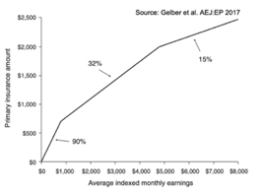
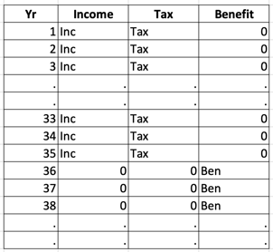
--> Take Best 35 yrs and average (ex. 3000) --> Apply replacement rate --> ex. 1400 retirement benefit

Key: (1) workers who earn more get higher benefits, but (2) benefits do not rise nearly as fast as earnings. Why we want it to be progressive?
Higher earners live longer (+12 yrs). The progressivity of benefits formula roughly offsets this.
replacement rate: how much are benefits received (primary insurance amount on you average indexed monthly earnings)
After individuals retire and receive a benefit, that benefit is adjusted upward for CPI each year to protect the elderly against rising prices.

3. When are social security benefits paid out?
Full Benefits Age (FBA): The age at which a Social Security recipient receives full retirement benefits (Primary Insurance Amount).
Early Entitlement Age (EEA): The earliest age at which a Social Security recipient can receive reduced benefits. In the US, it is 62.
If you claim benefits y year(s) before FBA, you get more or less y5% less in annual benefits (permanently).

4. Can you Receive Social Security at EEA and continue working?
- The earnings test reduces benefits of the 62 to FBA by $0.50 for each dollar of earnings they have above about $20K.
- These benefits are returned later when the worker’s earnings fall below this threshold.
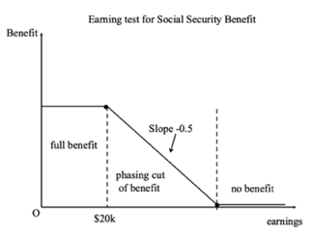

5. Are There Benefits for Family Members?
- Spouses of claimants (get own benefits or 50% of primary earner benefits, whichever is biggest)
- Spouses who survive a Social Security recipient
- Children of deceased workers

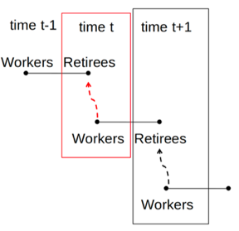
6. How are pension systems funded?
A. Unfunded (pay-as-you-go): Today I tax workers and pay retirees with the same money.
Total current benefits =Total current contributions
The first generation of retirees gets free benefits when the system starts (huge debt created). For later generations: you pay taxes for the older generation and you get benefits from the younger generation.
Generation t is size Nt , earns wt , pays taxes Tt = τNt wt and gets benefits Bt = τN_{t+1} w_{t+1} from generation t + 1.
$\frac{Bt}{Tt}$ = (1+n)·(1+g) ⇒ Implicit return on taxes: 1 + n + g + ng – 1 = n (pop. growth) + g (real wage growth).

ex. assuming 5% population growth and 5% wage increase. 1st gen completely subsidized. Last one end of the world.
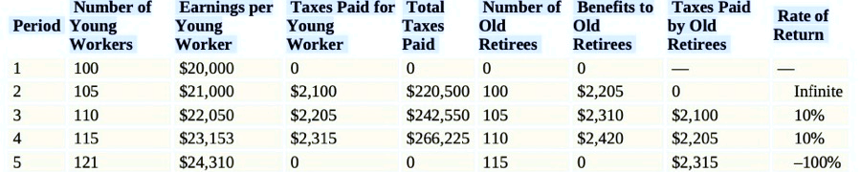

B. Funded: I tax workers today, invest their money, and give them back once they retire
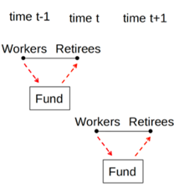
Current benefits = past contributions + market returns on past contributions

there is one fund per generation. Funded system: Each generation gets a market return r on contributions. Benefits = Taxes ·(1 + r)

Conclusion:
Funded system is always desirable when r > n + g All risk adjusted!

7. Things are getting bad (pay as u go in trouble)
A. Fewer and fewer people work at 65+ (80% at 1890, 20% rn)
B. Fertility is plummeting (elderly dependence index skyrocketing)
C. People are living longer and longer (life expectancy at 65 in UK in 1930 = +12 yrs, now + 20 yrs)
D. wage growth is slowing
people are retiring earlier and are staying retired (living) for longer. We use policy to fight this process (ex. raise retirement age)
solutions: go to funded system, raise payroll taxes, expand tax base, raise maximum taxable income, raise retirement age, lower benefits

8. Rationales for Social Security
Retirement is a predictable event that depends mainly on individual choice. Why should the government be involved?
A. Market failure in the annuities market weak()
The longer a person lives, the less money the insurer makes from an annuity contract. This could lead to such a high price for annuities that most people would not want to buy them.

B. Paternalisms
Life-Cycle: Individuals’ ability to work declines with aging (people become unwilling/unable to work).
Rational individuals would save while working to consume savings while retired. In practice, the optimal saving problem is highly complex: uncertainty in returns to saving, in life-span, in future ability/opportunities to work, in future tastes and health status, etc Gov. fears you will fail to save enough
Is this a real concern? or is there simply perfect crowd-out?
Evidence
1. Time series analysis: without pension some elderly ended up being very poor
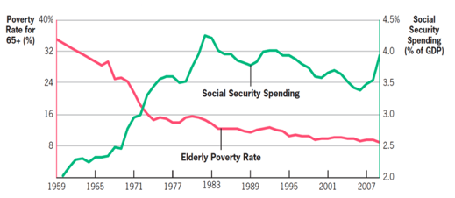
It works! however you know… time series are always problematic

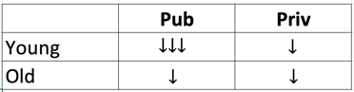
2. Did Italian Reforms 1992
The reform substantially reduced the benefits for younger workers in the public sector while reducing less the benefits for older workers and those in the private sector. This change set up a natural quasi-experimental analysis in which the researchers could assess whether the savings of younger workers in the public sector rose to offset the fall in future SSW. Studies estimate that only about 1/3 of the reduction in SSW was offset by higher private savings.

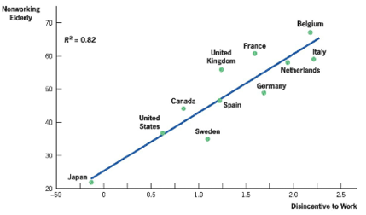
9. Can u retire 1 year later?
If a 62-year-old worker works until 68 instead of retiring at 67 , three things happen:
1) She pays an extra year of payroll taxes on her earnings.
2) She receives one year less of Social Security benefits.
BUT 3) She gets a higher Social Security benefit level through the actuarial adjustment (8% extra permanently per year of delay)
4) the average 35 yrs salary is higher
Adjustment is called actuarially fair if those three effects cancel out in PDV. US is fair. This balance is jey in affecting people’s choices. This PDV system creates disincentives to work

10. Retiring earlier or later?
Three key elements of a social security system may affect retirement behavior:
a. Availability of benefits at Early Retirement Age (EEA): how much u earn if you retire early
b. Non-actuarially fair benefits adjustments for those retiring after the FBA. If benefits are not adjusted equitably, they can create a substantial implicit tax on work.
c. Social norm: The gov calling some age the “Normal Retirement Age” can affect decisions despite no underlying economic incentives.
*retirement hazard: probability of retiring at a certain age

